# Experiment No: 01

**Name of the experiment:** Familiarization with MATLAB and Functions in MATLAB

**Objective:** To familiarize the students with MATLAB

**Software Requirement:** MATLAB 2014

Theory:

# Introduction to MATLAB

MATLAB is a high-level technical computing language equipped with a user-friendly interface. Its name stems from the words ***matrix*** and ***Laboratory*** as it is based on the use of matrices. MATLAB is an extremely powerful tool useful for scientists and engineers from various disciplines. For example, MATLAB can be used in a wide range of applications, such as telecommunications, signal and image processing, control, mathematics, financial modelling, bioengineering, aeronautics, and many more.

# M-Files

In order to write many commands that are executed all together, the program must be written in a text editor. In this editor, one can type all the needed commands to form a program, save the program, and execute it any time he or she wants. The text files are called *M-files* due to their suffice * .m.

There are two categories of M-files: the Scripts and the Functions.

# Scripts

Scripts are the M-files with MATLAB commands. Their name must have a .m suffix. Scripts are suitable for solving the problems that require many commands. The advantage of the scripts is that they are implemented very easily.

# Functions

Function are also M-files, That is, are files with extension .m and must be saved in the current Directory of MATLAB. The difference between functions and scripts is that a function accepts one or more input arguments and returns one or more output arguments. To declare that an M-file is a function the first line of the m file must contain the syntax definition. More specifically, the first line of the M-file must be of the form function[y1,y2,y3,…yn]=name{x1,x2,x3… xm}. The variable y1,y2,…yn are the outputs of the function while x1,x2,…xm are the input arguments. In case there is only one output, the square brackets are not necessary. The “name” specifies the name of the function. In order to execute a function, first the M-File is saved in Current Directory.

# Useful Commands

Here we will learn and practice useful (when working with vectors and matrices) commands. As already discussed, the command sumreturns the sum of the elements of a vector. The command cumsumreturns a vector whose elements are the cumulative sum of the previous elements, the command prodis the product of the vector elements, while the command diffreturns a vector in which each element is given by its subtraction with the previous element. The command max and min return the largest and smallest elements of the vector, respectively, as well as their index. The command sortsorts the

vector elements in ascending (by default) or descending order. The command mean computes the mean value, while the command medianreturns the median value. All these commands are suitable also for matrices by slightly changing their syntax.

# Lab Tasks:

1. Write a script file and execute.

# Editor:

columns = 1700;

rows = 1; % Set to 1 for one row

bins = round(columns / 40);

rng(now);

data = 50 * rand(rows, columns);

% Create histogram for the single row

histogram(data, bins);

title('Histogram for Row 1');

# Figure:

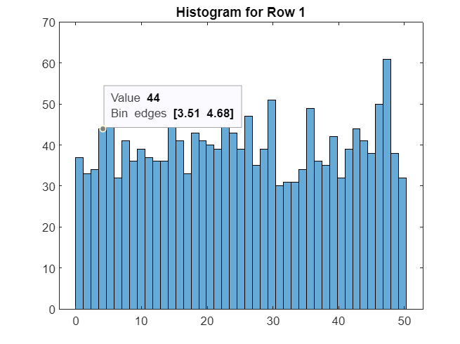

1. Write a function file and execute

# Editor:

function result = myfunction(x, y)

result = x^2 + y^2;

end

# Command Window:

>> x=2; y=3;

>> a=myfunction(x,y)

>> a = 13;

# Discussion:

MATLAB is a programming language renowned for its matrix-centric approach to data representation. In this paradigm, information is organized into matrices—structured arrays with rows and columns. MATLAB is equipped with an extensive library of pre-built functions that facilitate an extensive array of mathematical tasks. These tasks range from elementary operations like extracting square roots to more complex endeavors such as solving systems of equations or generating graphical plots.